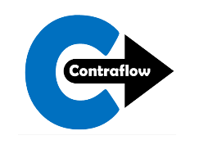

Young Person Registration Form 2020/21

I give permission for my child to be transported by appropriate volunteers or parents to events with Contraflow: Yes  No

**PARENTAL CONSENT**

I confirm that the details are correct and complete to the best of my knowledge. In the event of illness or accident, I give permission for any necessary medical treatment to be given by the nominated first-aider. In an emergency and if I can’t be contacted, I am willing for my child to receive hospital treatment, including anaesthetic if necessary. I understand that every effort will be made to contact me as soon as possible.

Parent / Guardian Signature Title First Name Surname

I am happy to receive information about future events which may suit my child from Contraflow: Yes No

My child is under 16 and I give consent for their photo/video to be used for publicity purposes of Contraflow : Yes No

We promise to look after your data in accordance with General Data Protection Regulation. It will only be disclosed to Contraflow (charity no. SC027973). For more details, visit www.contraflow.org.uk/privacy.pdf

Emergency Contact Name

Male Female

Child’s First Name

Child’s Surname

Date of Birth

Address

Post Code

School

Any known allergies, health problems or additional support needs:

Email (Parent/ Guardian)

Phone (Parent/ Guardian)

School Year in August 2020

Emergency Contact Phone

The child may be collected by

Please tick if the child can go home unaccompanied

GP’s Phone

GP’s Name